Long Term Overview: The Reading Journey for Year 2 2022-23
Non-Fiction Fiction Poetry Author focus Longer Narratives – read during class storytime.
Autumn 1 | Autumn 2 | Spring 1  COLLECT READING TAFS | Spring 2  COLLECT READING TAFS | Summer 1  SATS MAY | Summer 2
Reading Journey 1  National Poetry Day October | Reading Journey 1 | Reading Journey 1 | Reading Journey 1 | Reading Journey 1 | Reading Journey 1
History  HISTORICAL HEROES  INFORM  Florance Nightengale  (Inspiration, British Values)  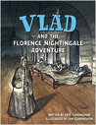  POETRY  Literacy Shed +  Lady with the lamp  INFORM  Stevie Wonder  (Diversity, Inclusion and Inspiration, British Values)  Vipers Questions  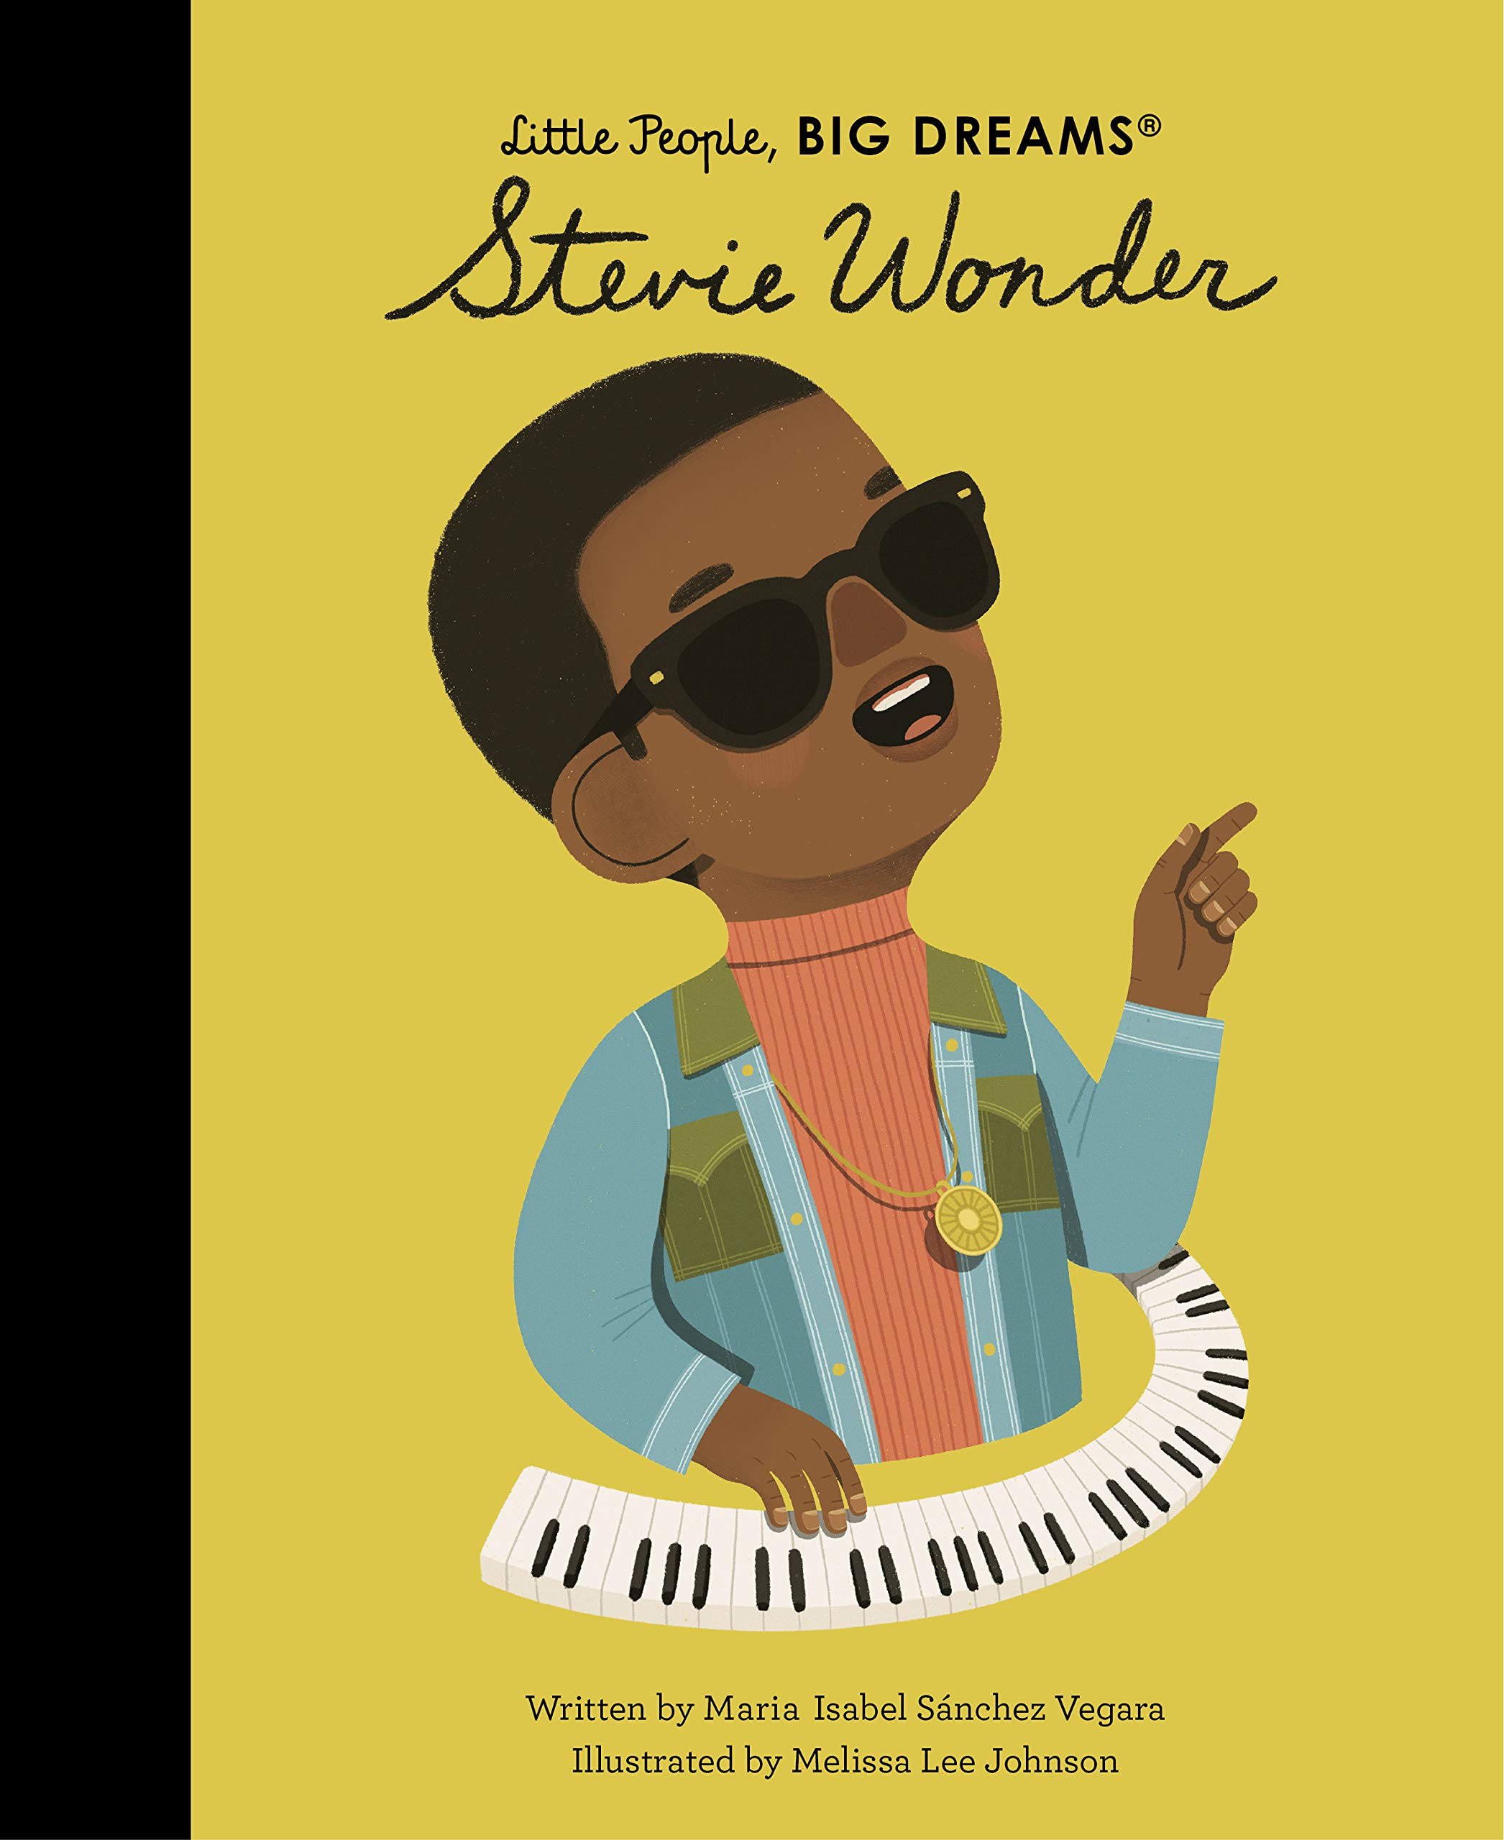 | History LONDON’S BURNING  RE Advent  INFORM  The Great Fire of London  Vlad the Flea  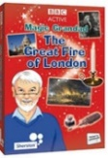  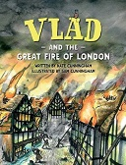  Literacy Shed: Pudding Lane, Magic Granddad.  INFORM  Literacy Shed + The Great Fire of London: Samuel’s Diary  INFORM  (British Values, CST, Environmental and Sustainable Citizenship)  Author focus Oliver Jeffers  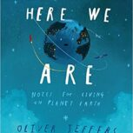 | Geography  WE ARE GOING ON A SAFARI  ENTERTAIN  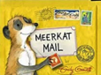  Meerkat Mail  ENTERTAIN  Author focus Helen Stephen  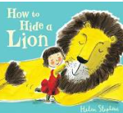  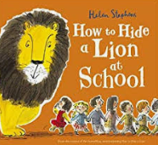  ENTERTAIN  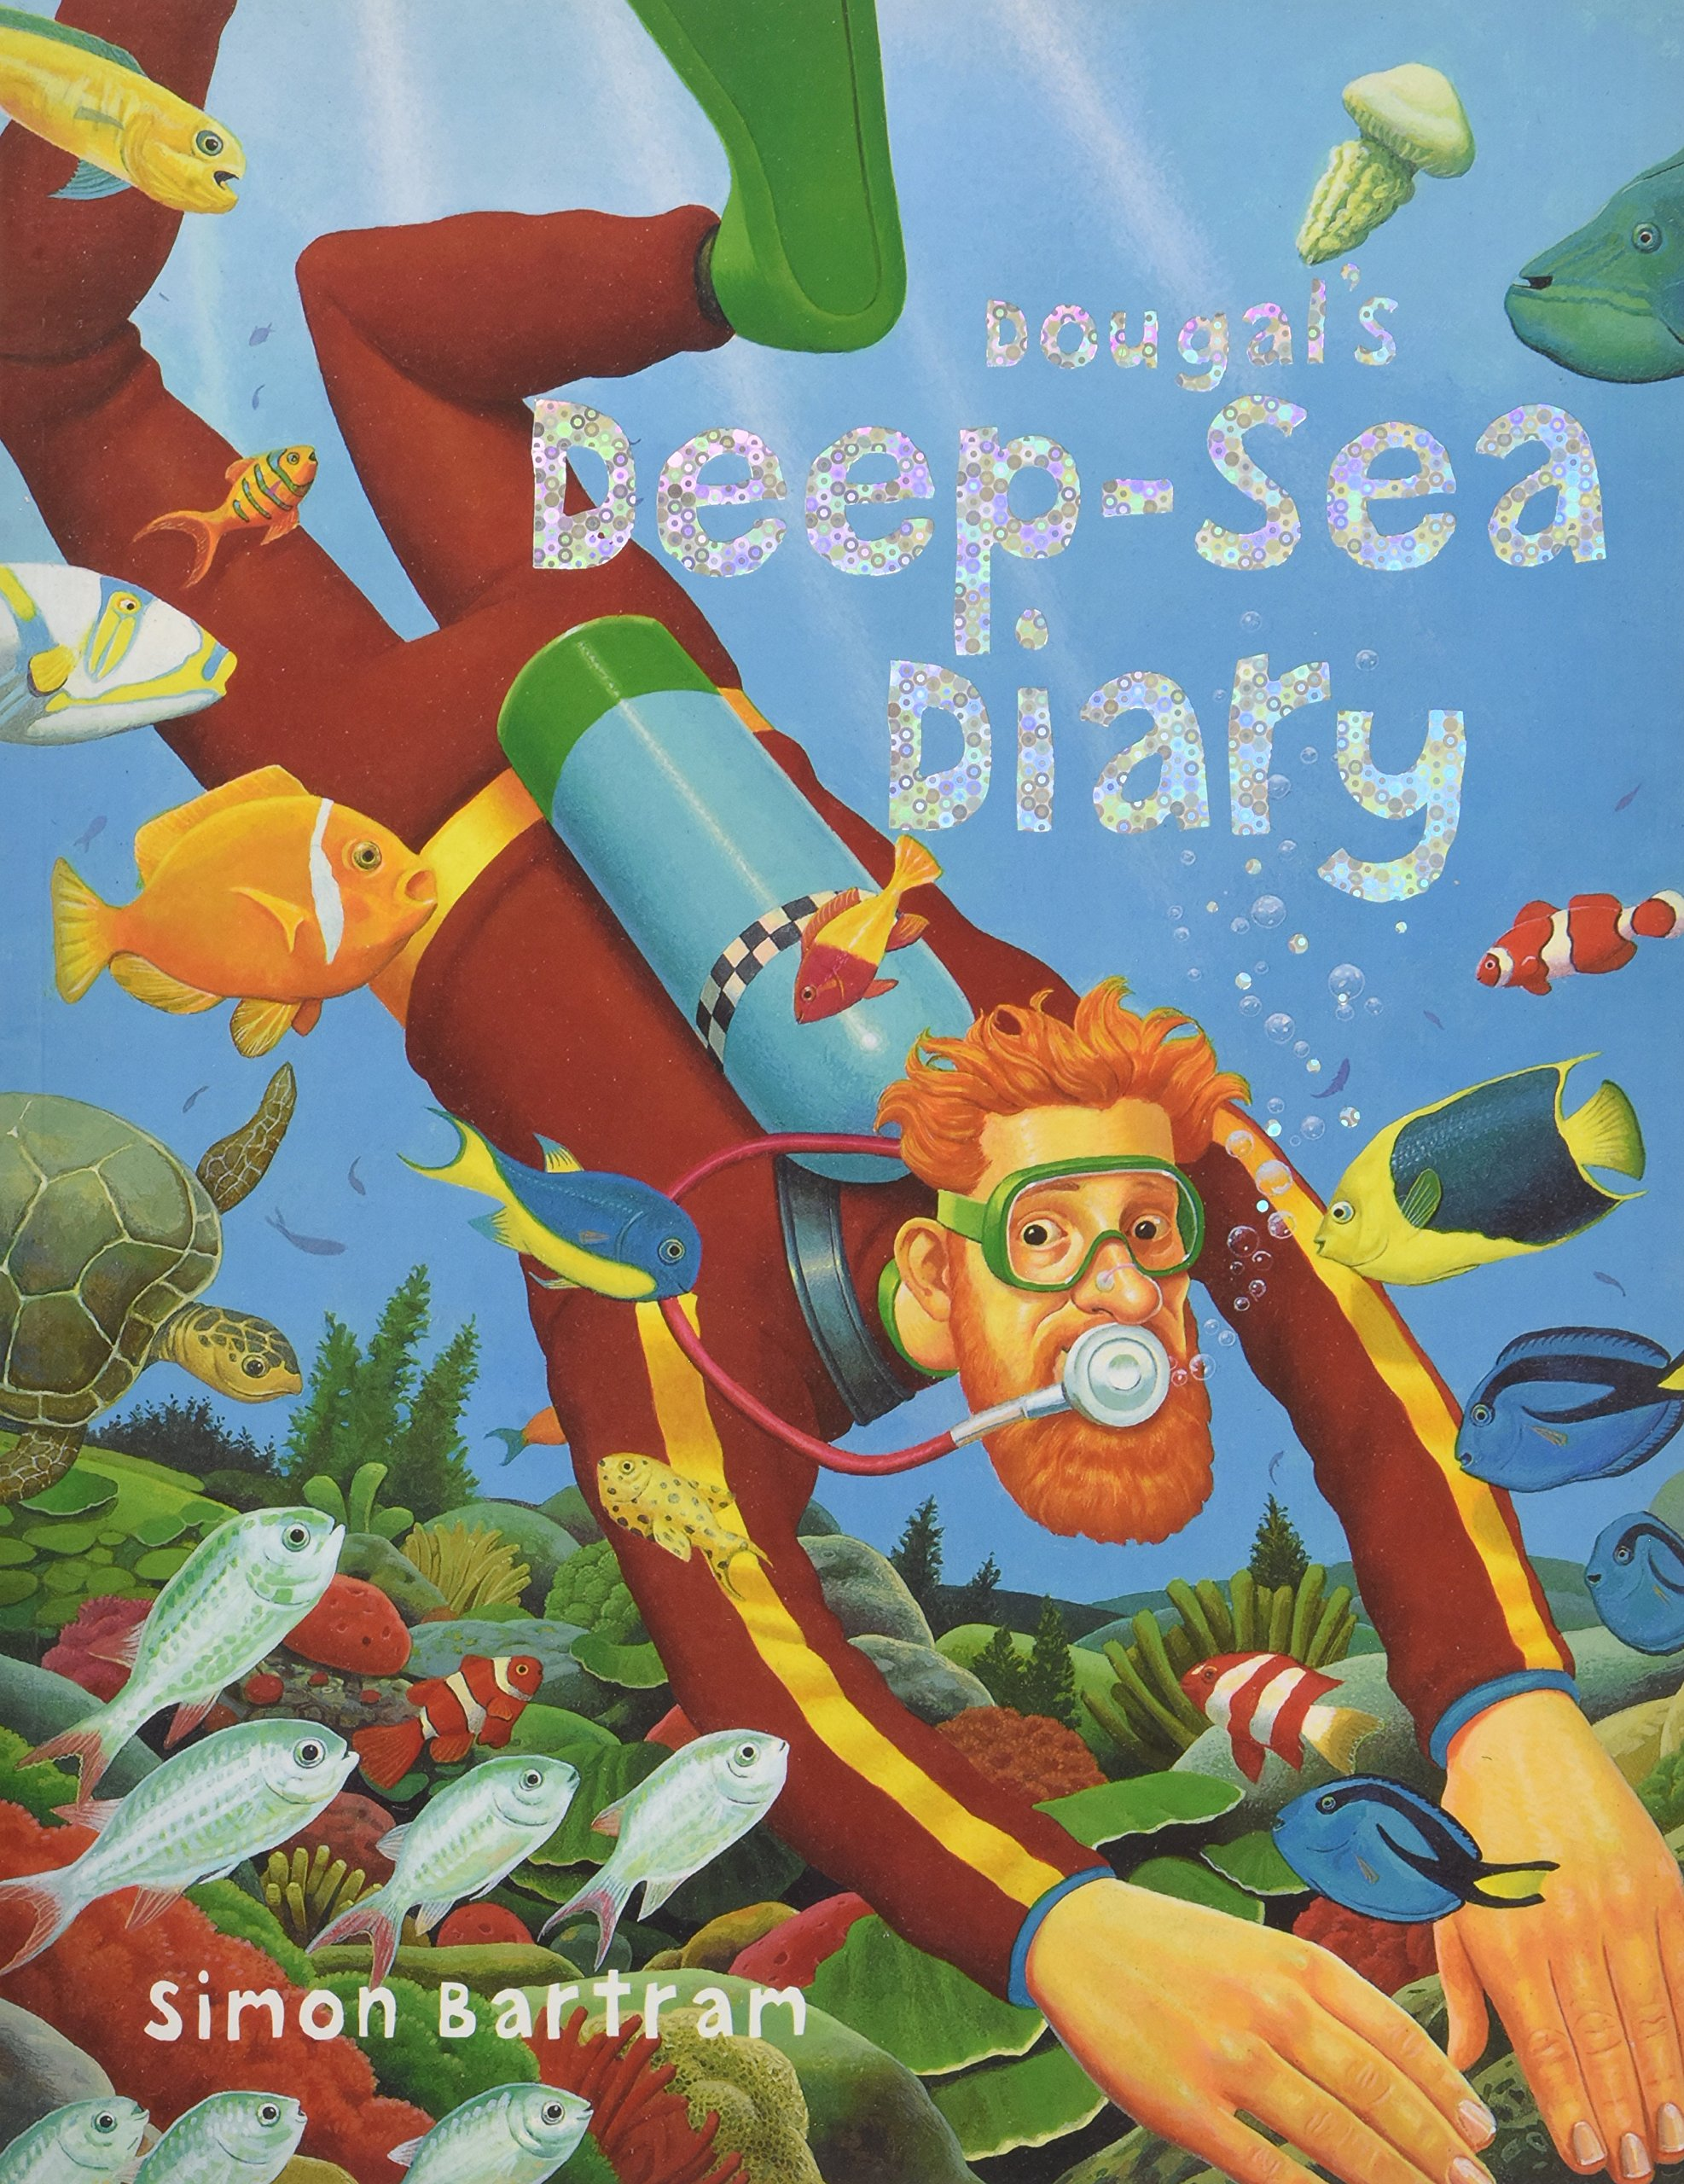  Author focus Simon Bartram Dougal’s Deep-Sea Diary  (Reading TAF evidence)  ENTERTAIN + POETRY (through story time not reading lessons)  Author focus Julia Donaldson  Poetry Focus  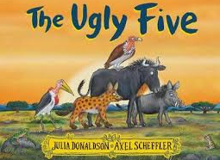  The Ugly Five  IF TIME = INFORM  Literacy Shed + Safari: Kenya | Geography  WE ARE GOING ON A SAFARI  ENTERTAIN  The Three Little Wolves and the Big Bad Pig (Week 1 -2 and Week 3-4)  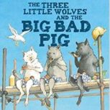  If time (Whole Class if time if not just as a challenge for GD pupils):  COMPARE TO THREE LITTLE PIGS TRADITIONAL TALE.  ENTERTAIN  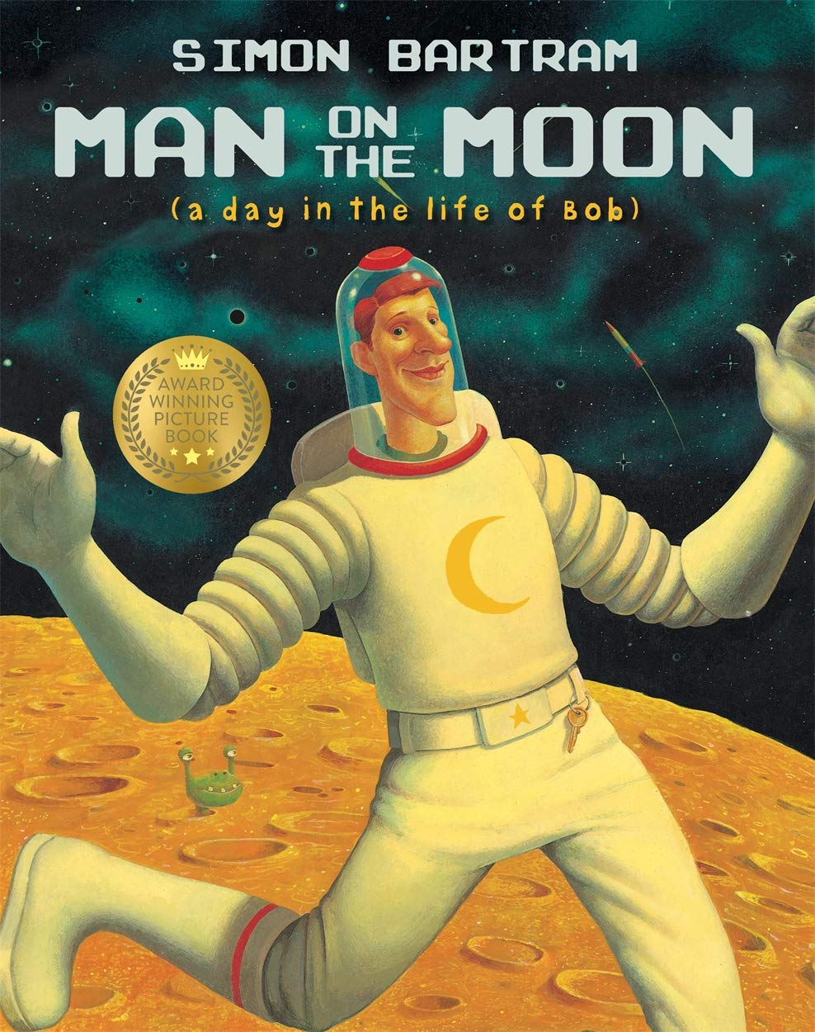  Author focus Simon Bartram Man on the Moon  (Reading TAF evidence)  SAT PAPERS PRACTICE  Easter Story  BACK UP IF NEEDED FOR EXTRA EVIDENCE  ENTERTAIN  The Pea and the princess  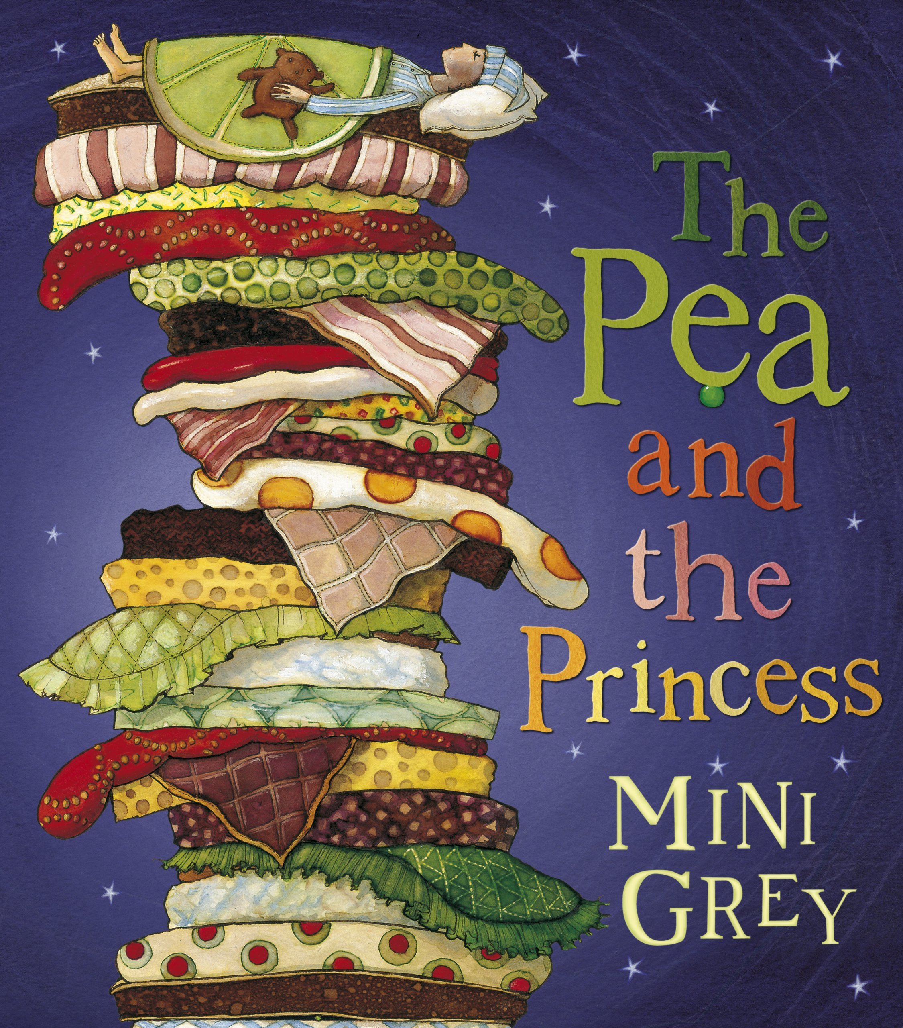  (Reading TAF evidence) | Geography and History EPIC EXPLORERS  POETRY  Literacy Shed + Antarctica: A visit to Antarctica  INFORM  Little People Big Dreams Amelia Earhart  (Inspiration)  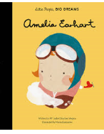  ENTERTAIN:  Only if needed  The Bear and the Piano  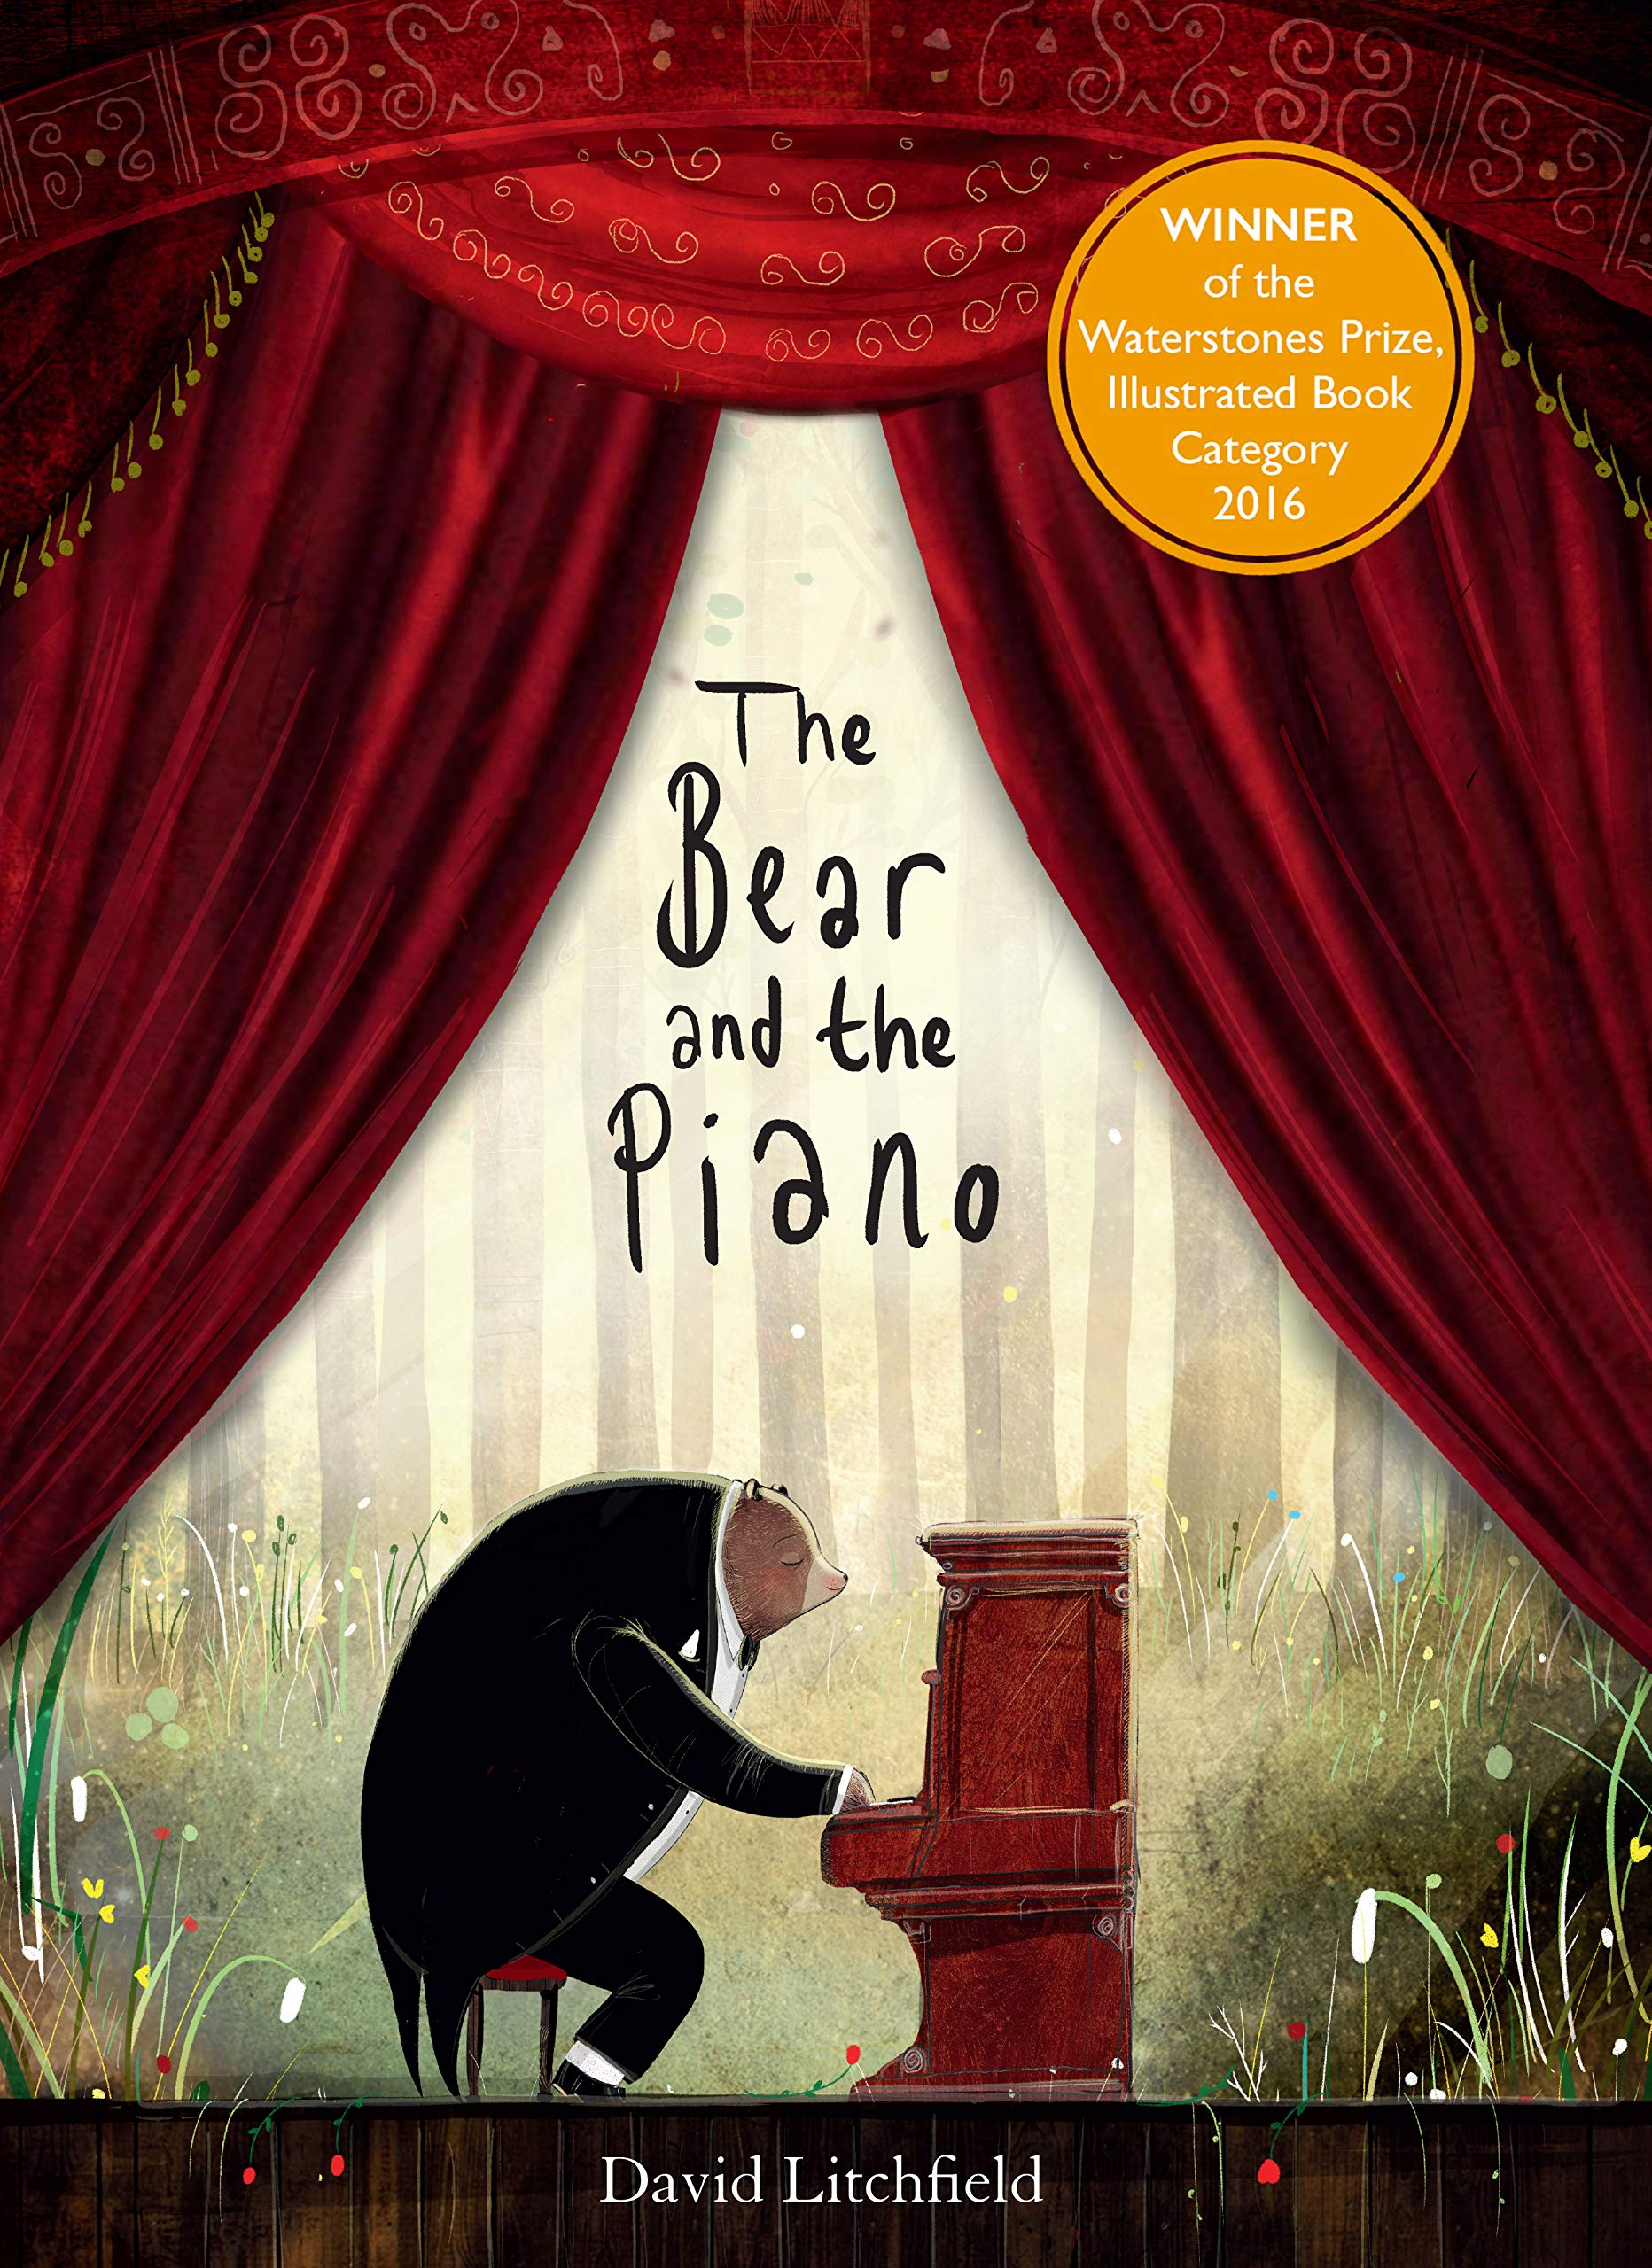  (Reading TAF evidence)  SAT PAPERS & PRACTICE  If time (Whole Class if time if not just as a challenge for GD pupils):  TRADITIONAL STORIES GD COMPARISONS GOLDILOCKS COMPARE TO THE TRADITIONAL TALE.  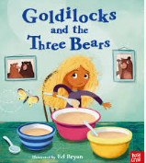  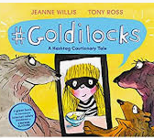 | Geography and History  OH I DO LIKE TO BE BY THE SEASIDE  INFORM  (Inclusion and Inspiration, British Values)  Splash  Vipers Questions  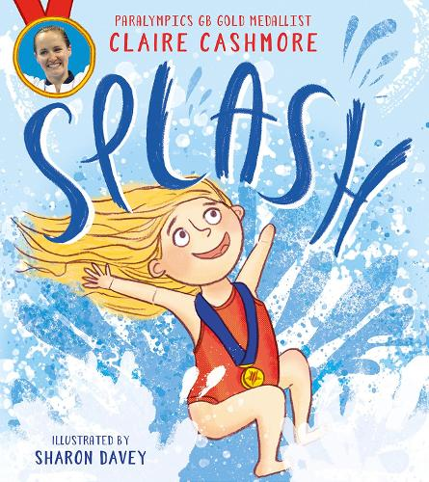  ENTERTAIN  Flotsam  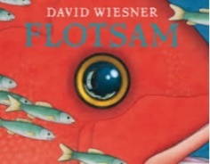  ENTERTAIN  Pirates Next Door – Jonny Duddle  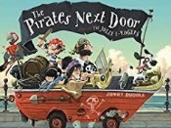  POETRY  (Narrative Poetry)  Sully the Seahorse  